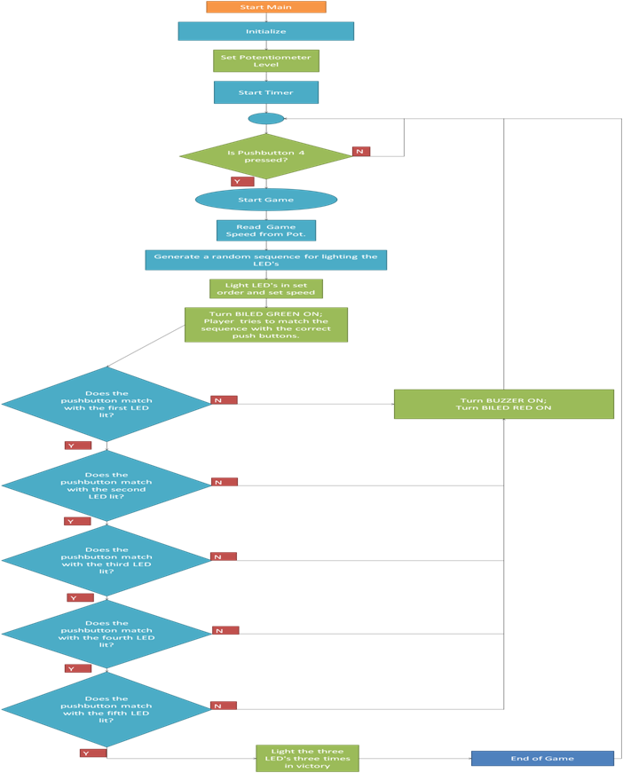

b. Software Descriptions

**Legend**  
Hardware  
Software  
Yes/No